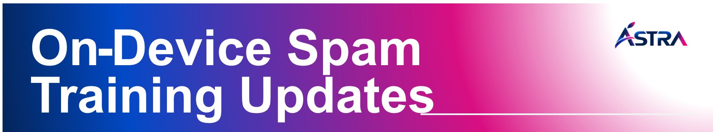
Date: Sep 28, 2026
Attendees:
Batch Status & Throughput Summary

Batch details |  |  |  | Attrition (or) Move to different batch |  |  |  |  | Current State & Throughput
Wave | Planned HC | In Count | Delta | FX | PST | NST | Total ATT | Movement | Certified | Throughput (%)
1 | 17 | 17 | 0 | 0 | 0 | 0 | 0 | 0 | 0 | 100%

Training & Content Updates

- All 17 planned trainees attended the training, achieving 100% attendance for Wave 1 – ODS batch.
- The Trainer introduced Sutherland, and the nature of work handled by the team.
- Conducted a walkthrough of key Sutherland platforms, including SAP SuccessFactors, iRoz, and Workzone HR, and advised trainees to install the One Sutherland application on respective phones.
- The Trainer guided trainees to complete the mandatory Sutherland onboarding courses available in My Learning.
Topics & Activities Covered

- Conducted an icebreaker activity to encourage team interaction and engagement.
- Provided an overview of Sutherland, introduced the key tools, and discussed the scope of work.
- Covered access and navigation for key HR and employee platforms.
- SD Manager shared guidance with the trainees on transportation access and related support processes.
- Reinforced completion of mandatory onboarding learning modules as part of the initial training requirements.

Action Items

- ID Card: Trainees have submitted their photographs, and the Training Manager has raised the request with the Security Team for further processing.
- Laptop Assignment: Pending completion of BGV clearance by the TA Team.
- Astra Credentials: To be initiated upon successful completion of the BGV process by the TA Team.
- Meet & Greet: Session scheduled with the respective Sutherland teams to facilitate introduction and team alignment.
- Training Updates: The next update will be shared once the BGV clearance is completed for all agents.
Tools Access and Status

- Astra credentials – yet to generate – BGV pending.

